

Few words from the President

The Radio Sport Modelisme Aulnay will be proud and really happy to organize the 1/8 scale European Champion ship in Tremblay en France on 2006.
The RSMA track and all the facilities ( hotels, restaurants, commercial centers, train station) are located near the Roissy Charles de Gaulle airport ( 5 minutes by car ).
You can enjoy your race by visiting Paris or the two attraction park centers, Disneyland Paris, 20 minutes by car or 10 minutes by TGV and Asterix Park 15 minutes by car, or by shuttle.
On the track, you will find all the facilities for your race : air compressed on the car cleaning table, turn-tyre table, electricity on all the tables, body water cleaning space, 3 video screens plus an audio public address system for your race informations.
The two counting systems are digital AMB RC.
You will find also all kind of refresments, hot and cold meals, breakfast, and the RSMA specialty : the barbecue crapes!
On the Thursday or Friday night the Radio Sport Modélisme Aulnay will organize a party after the race, so the funny time will take place at 7.oo pm to,,,,,,am ?
So,,, welcome to France et welcome to the Radio Sport Modélisme Aulnay for this 1/8 scale European Champion ship, all the team will do his best for giving you very good memories of this race.
Personnal regards and see you soon in Tremblay en France.

Patrick THIOUX
RSMA President
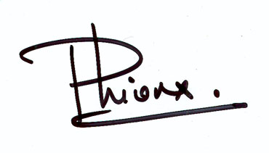

Radio Sport Modélisme Aulnay



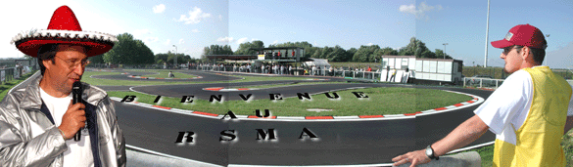
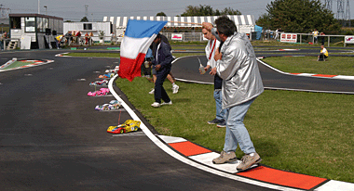  Départ d’une finale Coupe de France 2002  French Cup 2002 | 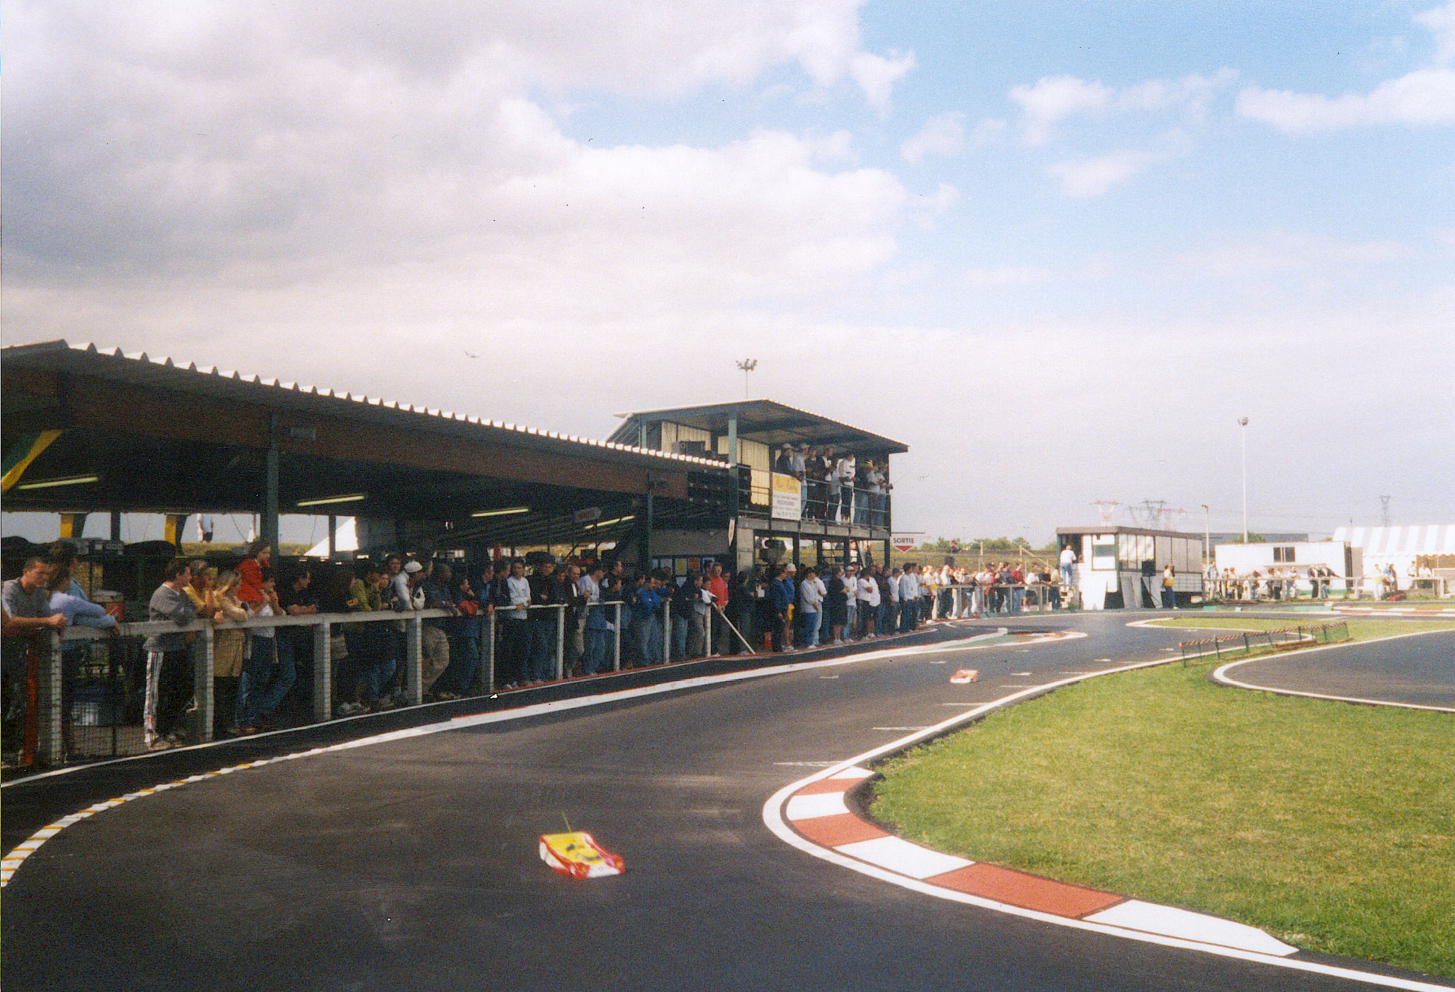  les stands – le podium  the rostrum
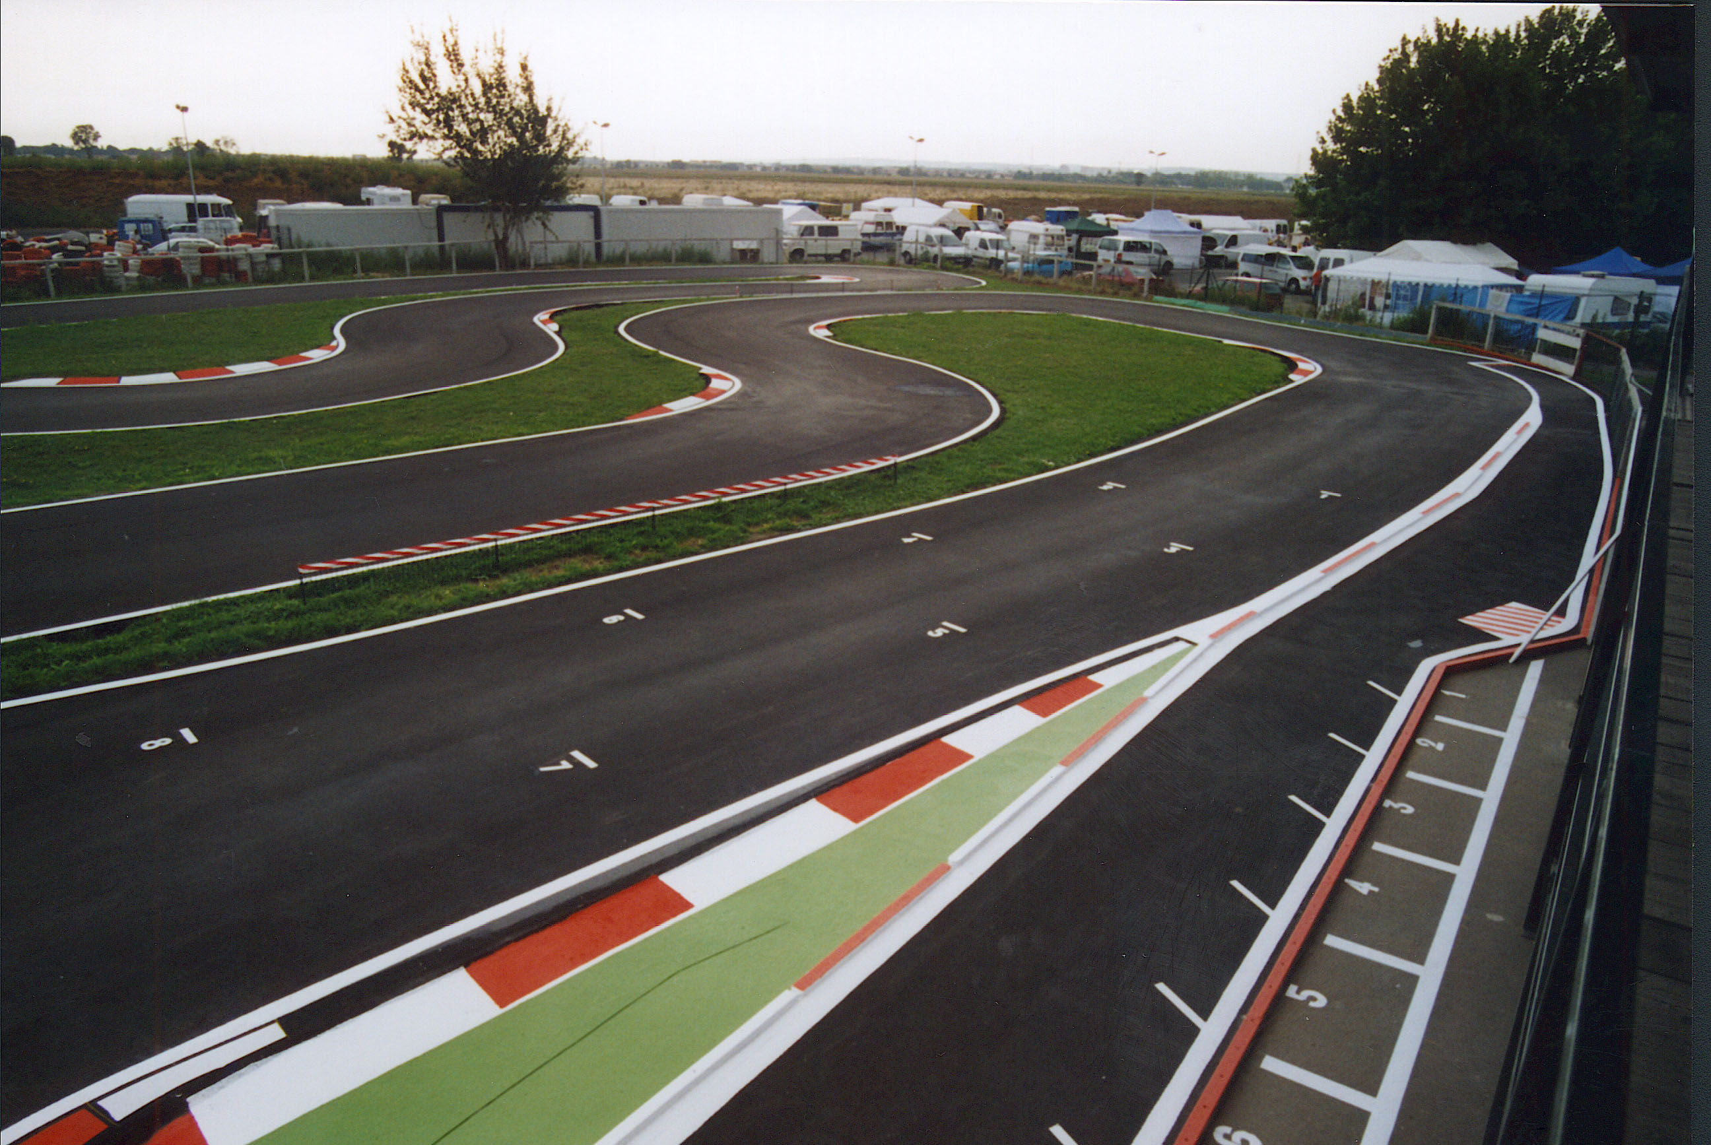  vue du podium rostrum view |  | 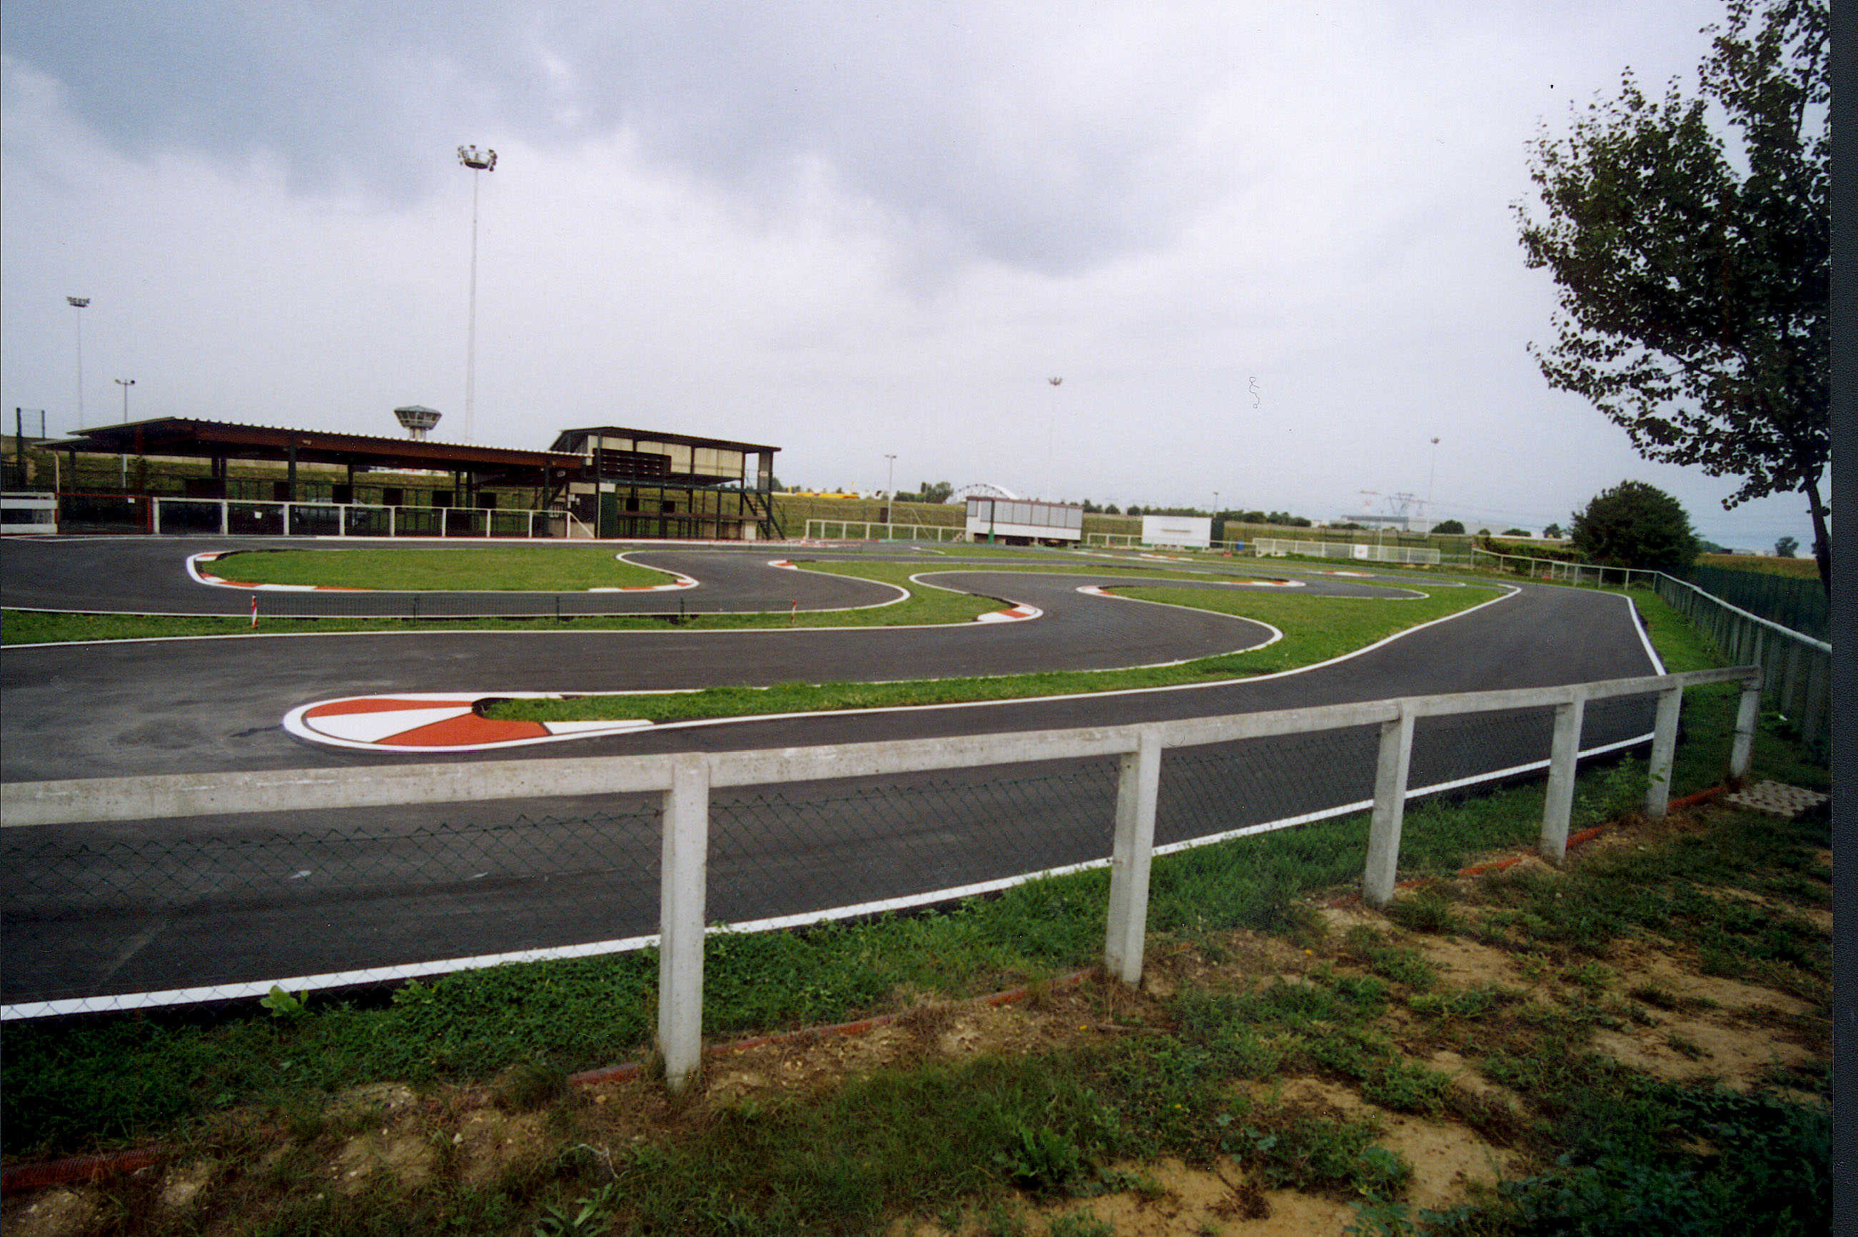  vue générale du circuit général view
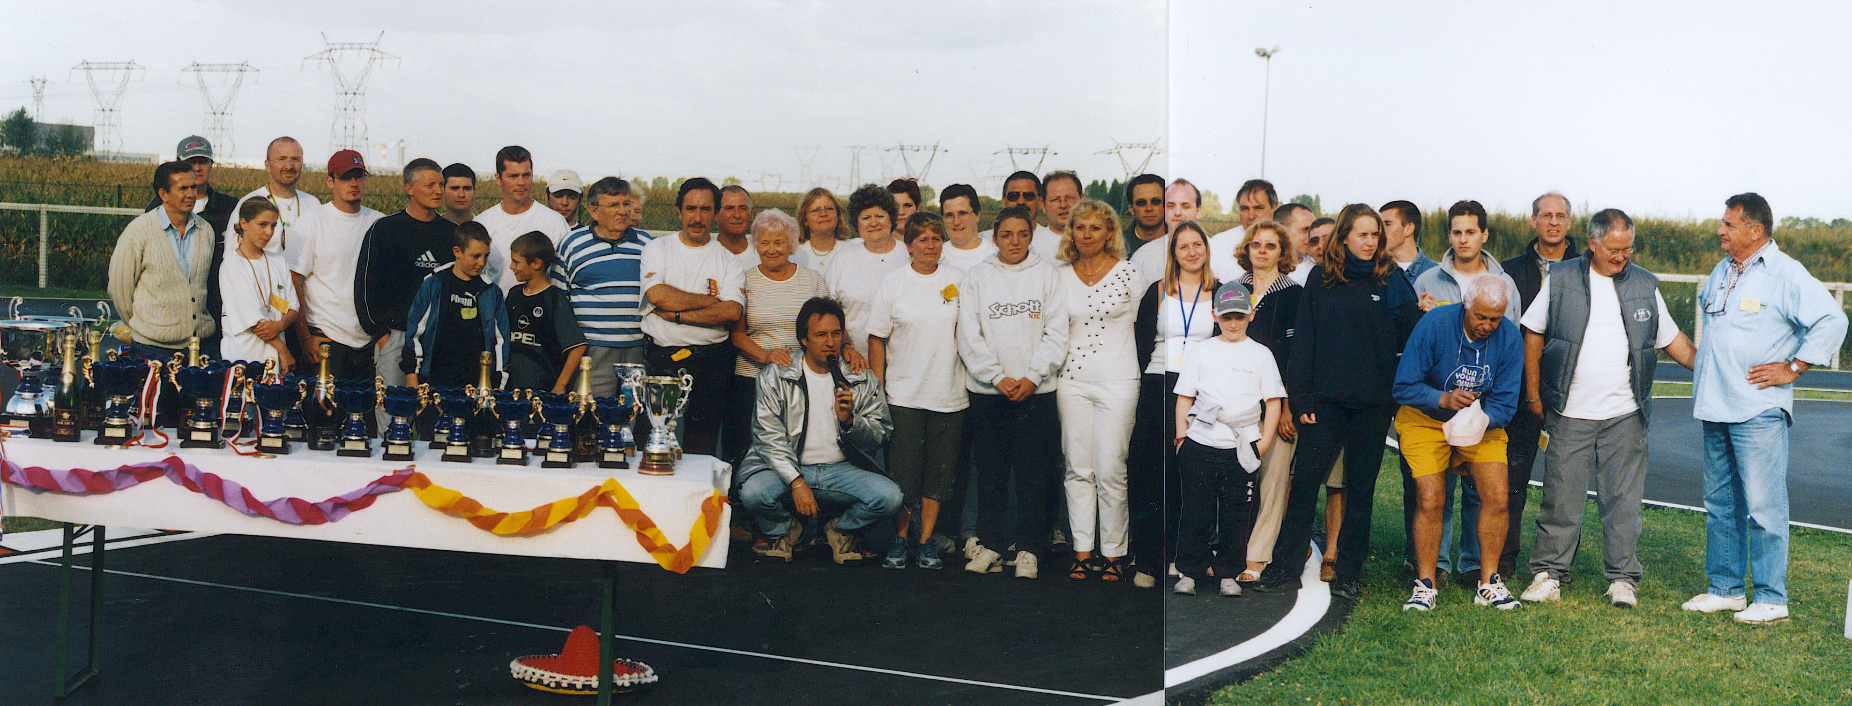  l’équipe du RSMA RSMA Team organisation |  |  | 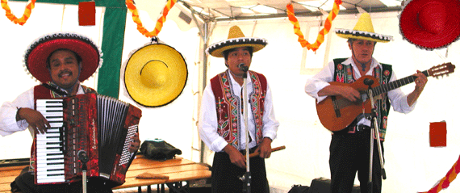  Fiesta au RSMA Evening RSMA fiesta



100 Bld de Strasbourg

93 600 Aulnay Sous Bois France

: 33.1.48.79.99.91

e-mail address : rsma@wanadoo.fr
web site http://perso.wanadoo.fr/rsma

Access Map

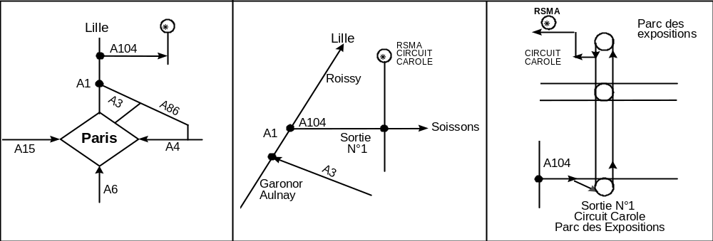

Track features

Address : R.S.M.A. Circuit CAROLE Chemin départemental 40 93290 TREMBLAY en France

Lane : | lenght : 340m width : 5m | Electricity stand 220V : | yes
Facing : | Tar : 0.4 mm grain | Refreshment-stand : | yes
Rostrum : | lenght :12m width : 2,50m | Meal : | Hot and cold
Parking : | 200 places | Toilets : | yes
Stand : | permanent | Tribunes : | no
Air compressed : | yes | Camping : | no



